Introduction
Welcome to your favorite AICT Lab. In this lab manual, we shall work together to learn and implement new computing concepts.

Skills to be learned:

- MS Office
- MS WORD– Document formatting, tables/images, mail merge, references, collaboration.

Week 2 | Computer Components  Use MS-WORD:  - To write Application to the chairman  - To write Paragraph on first day fooling  - To Design and create three folds pamphlet  - To Create Bio-data form | CLO1

Let's do some computing

Good Luck and Best Wishes !!
Happy Computing ahead :)

MS Office

MS WORD
Professional
Documentations

INTRODUCTION TO MS WORD

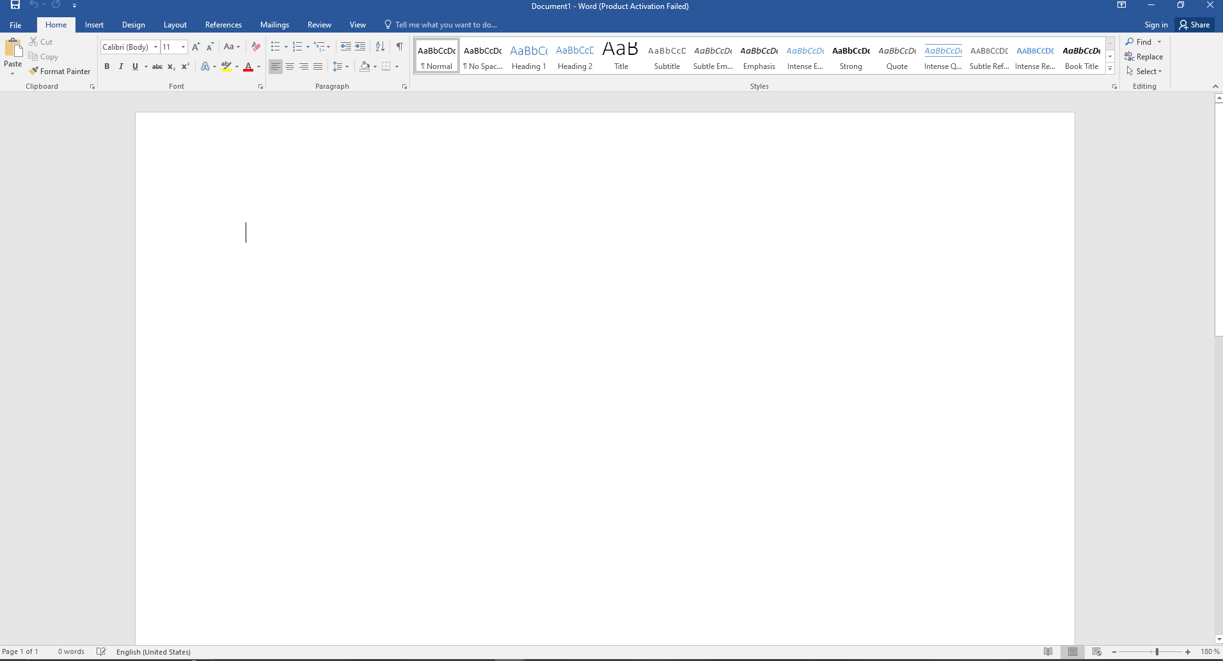
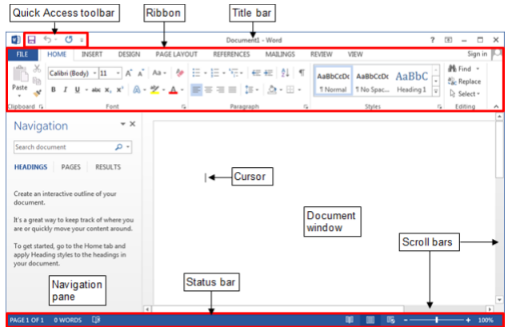
Figure 1-MS word program window.
MS word is a program used to create, edit and save professional documents such as reports, applications, resumes etc. It has many powerful features that make it easy to use and give a professional look to your documents. Its important parts include menu bar, standard toolbar, title bar, formatting toolbar.
Title bar:
Title bar contains the name of the document. The buttons on its right side are used to minimize, restore, maximize and change the display of ribbon.
Cursor:
The vertical blinking line which indicates where text and objects will be inserted.
Menu bar:
The menu bar contains all the menus of words which have many useful features.
Standard toolbar:
The standard toolbar contains the shortcut of most widely used features.
Formatting toolbar:
It is used to format the text. It can make text bold, italics and underlined. It is also used to change the colour of text.
Scroll bar:
It is used to scroll the document.
Status bar:
It shows the status of different toggle keys and actions being performed in the document.
STARTING MS Word
Ms Word can be started by clicking the start button and then all programs and selecting Ms Word from Ms Office or you can type WinWord on the search windows search bar to start Ms Word. Select the blank document, a new document will be opened.
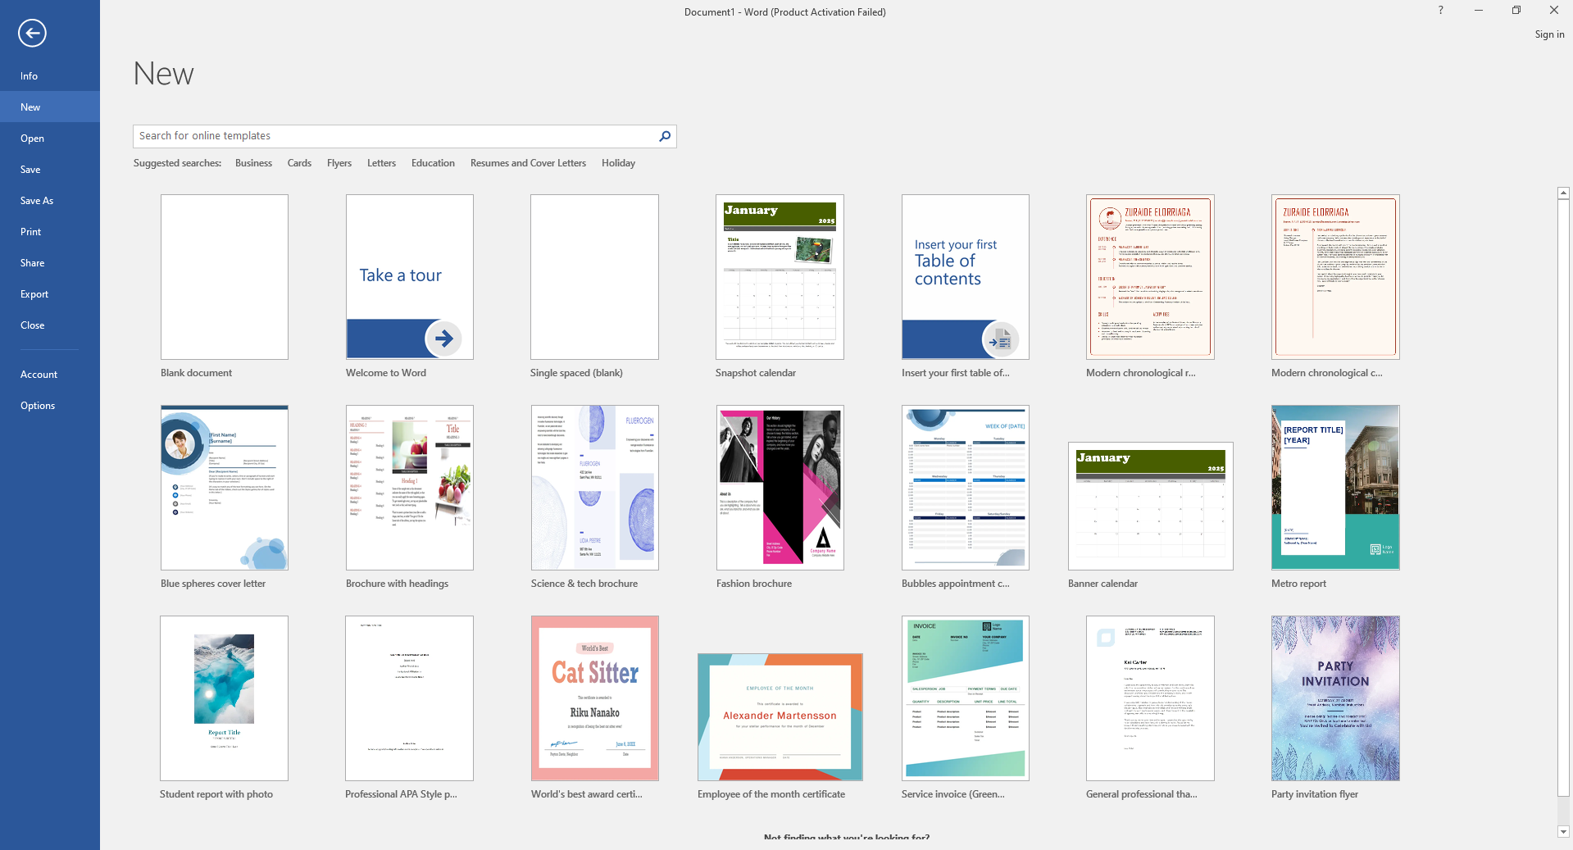

Figure 2-blank document
Some Important features of MS Word
File tab: File menu has many important features which includes save which is used to save documents, open used to open saved documents, new used to open new blank document and print used to print documents.
Insert tab: It has many options like inserting table, pictures, smart art, charts, header and footer.
Home tab: It is used to change the appearance of text. It can make text bold, italics and underlined. It is also used to change the colour spacing and alignment of text.

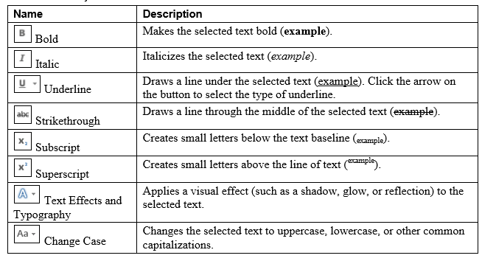
Figure 3-font group and text effects
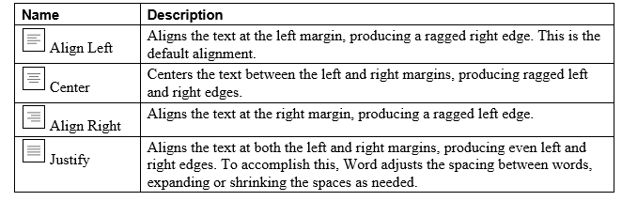
Figure 4-alignment buttons
Design tab: It contains commands related to changing the overall appearance of a document such as page borders, page colours and watermark etc.
Exiting Ms Word
You can exit a word by clicking the close button in the upper right corner of the title bar. Or by selecting file menu and click on close option
Some most widely used short-cut keys:
Ctrl+P | Printing a document
Ctrl+V | Paste
Ctrl+X | CUT
Ctrl+C | Copy
Ctrl+Z | Undo an action
Ctrl+Y | Redo an action
Ctrl+O | Open a new document
Ctrl+S | Saving a document

CS-141L Introduction to computing
Write an application to the chairman of the department for the change in discipline.
Objectives
To get familiar with Microsoft word environment and get to know how to make simple documents using formatting features of Ms Word.
Processing steps
Opening blank document
1-Start Ms Word from the start button as mentioned above. And open a new document by clicking on new option and selecting blank document.
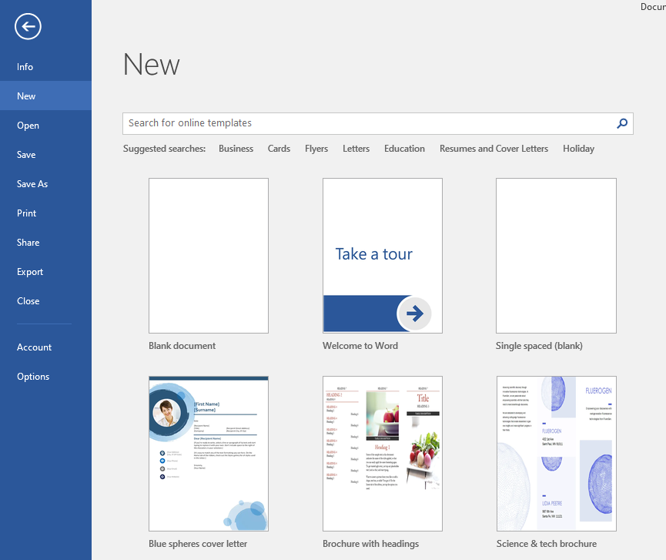

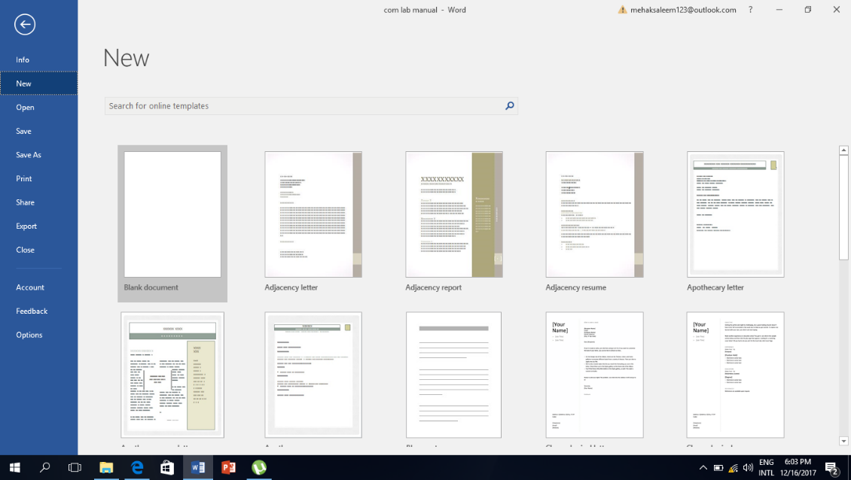

Figure 5-new document
2-Start typing in the blank working area according to the given format.
Formatting text
3- Appearance of documents can be changed. You can make the heading bold, italics and underlined. Select the text you want to format. On the Home tab from the font group, font size and style can be changed.
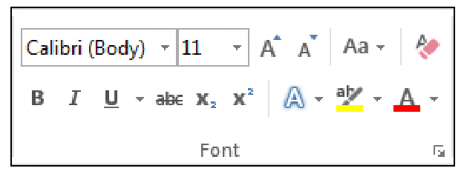
Figure 6-font group

4-Font size can be changed by clicking the font size arrow and selecting the desired font.
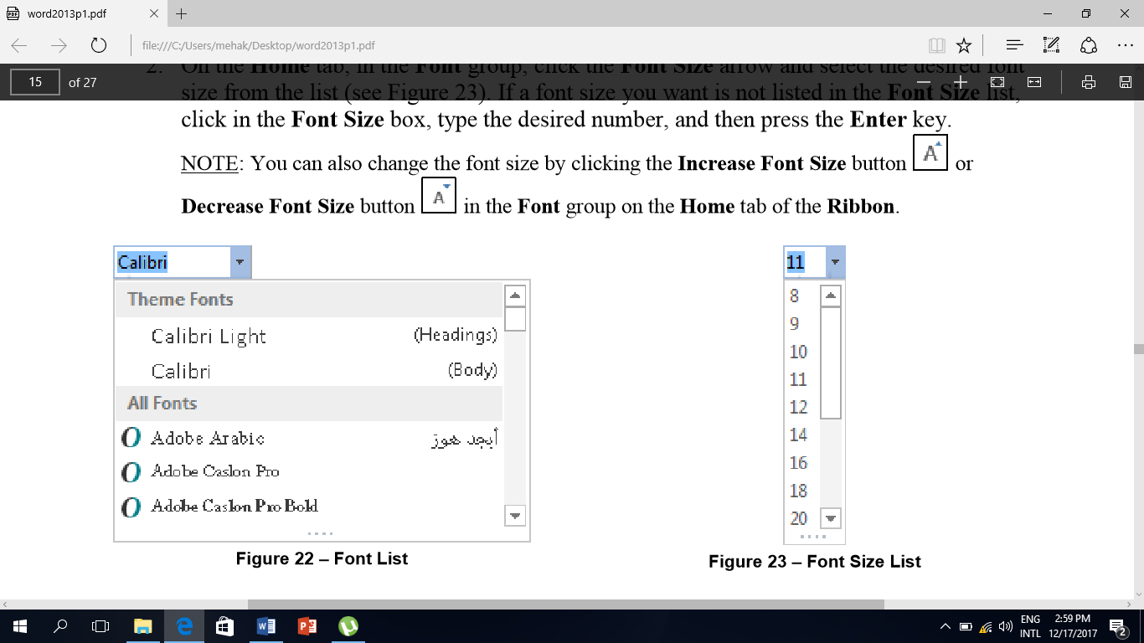
Figure 7-font size
5-Font style can be changed by clicking the font arrow and selecting the desired one.

Figure 8-font style
6-Change Indentation and alignment of the text if needed. The text in the application can be left, right, centre and justified. Indention of the paragraph can be increased or decreased. All this can be done from the Home tab in the paragraph group.
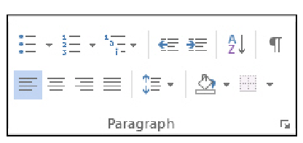
Figure 9-paragraph group
Saving document
5-After all the formatting, the document can be saved. To save a document click on the File tab and then select “Save As”. Click on the browse button.
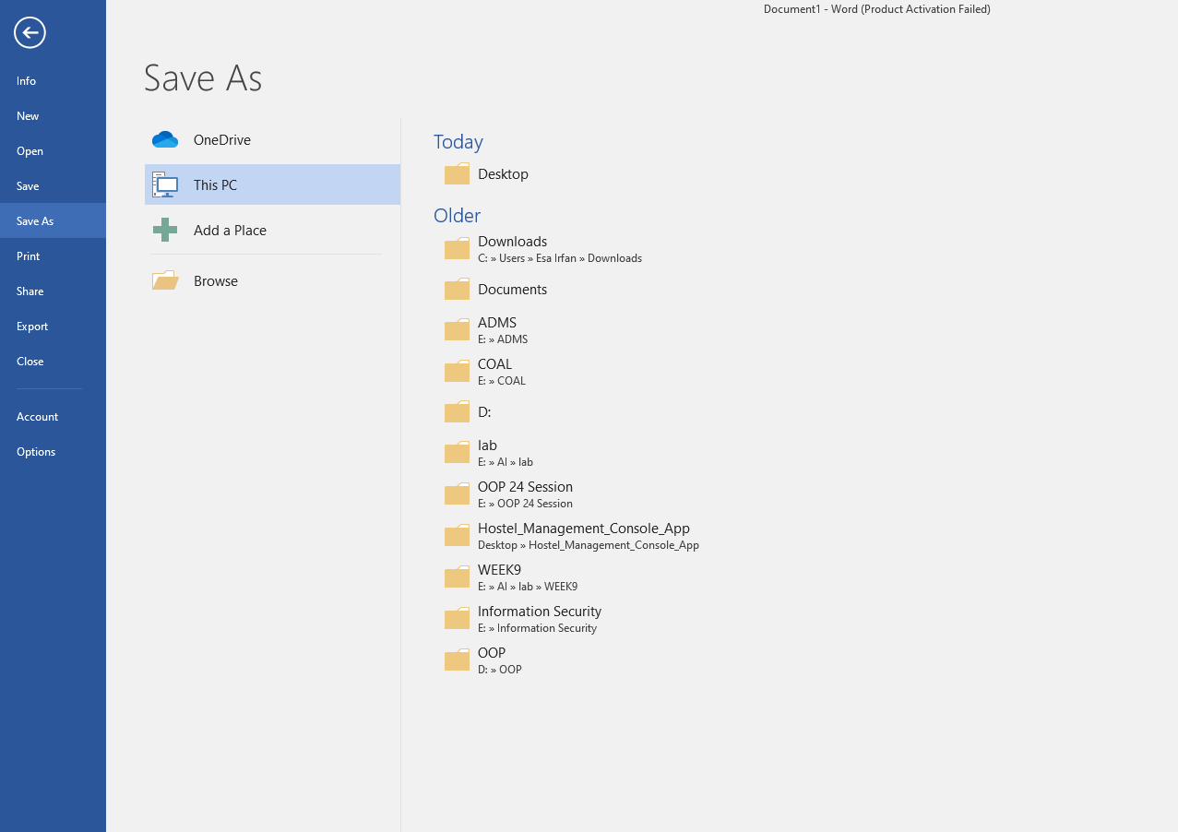
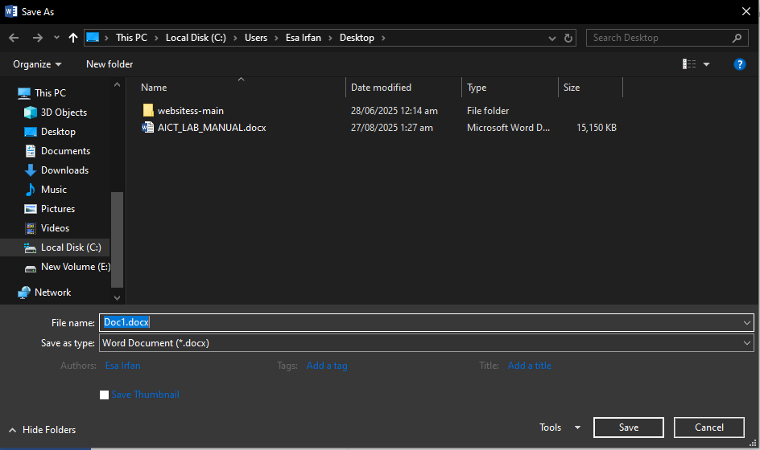
Figure 10-saving a document
6- The save as dialog appears. Enter the name of the file in the bar next to File Name. And in the “Save As Type” box enter the format in which you want to save the file. Then press OK, the file will be saved.

Conclusion:
After following the above steps, users would be able to create, format and save applications. Users can make Professional documents with these simple steps. These are the most basic operations; one can perform using Ms Word.

REFERENCES
- “Basic tasks in MS Word 2016.” Internet, https://support.office.com/en-us/article/Basic-tasks-in-Word-2016-5ddb2058-7744-4b53-b14d-976acafbaba6,
- “Introduction to MS word.” Internet, https://support.office.com/en-us/article/Basic-tasks-in-Word-2016-5ddb2058-7744-4b53-b14d-976acafbaba6,

Sample:

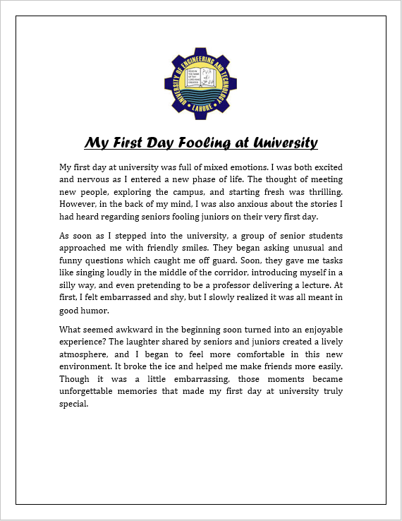Figure 12: Sample document

CS-141L Introduction to computing
Design and create a 3-fold pamphlet using MS-word.
Objectives
To learn how to use MS-word template and create your own document in a desired format.
Processing steps
Start MS-word. Click on the File tab and then new option.
Using template
To select template, go to the File tab and click New. Click on sample template or search flyer in the search bar.
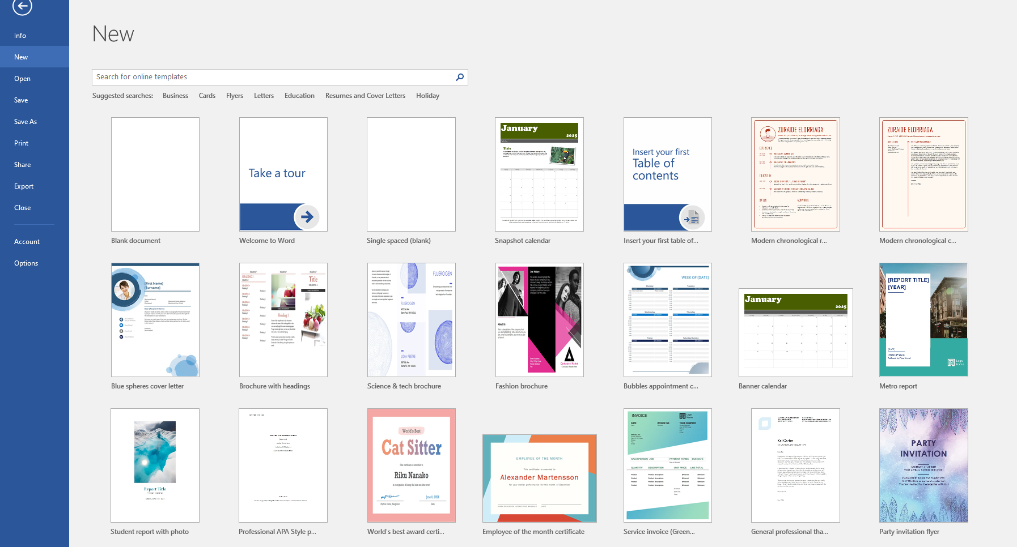
Figure 27-selecting template

- Select the flyer template as follows.
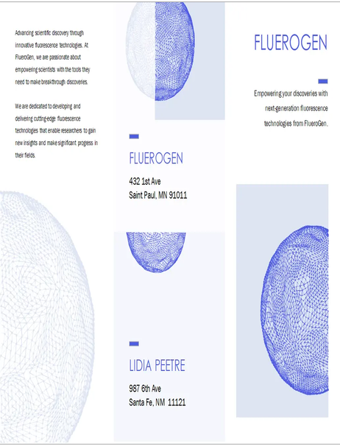
Figure 28-using flyer template
- Make changes in the template according to requirement. Insert pictures in the pamphlet and format them if required.
- Add text related to the task and format it. Change font colour and font size if required.
Applying bullets and numbering
- Add bullets to the key offerings in the pamphlet. To do this select the text and then in the home tab in the paragraph group select the bullets and numbering option to apply them.
- To change bullets and numbering click the arrow in the bullets and numbering button and select the desired look.

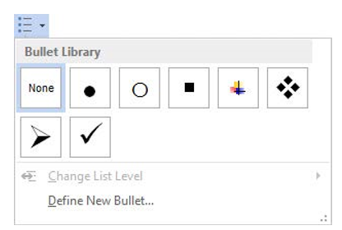
Figure 29-changing bullets
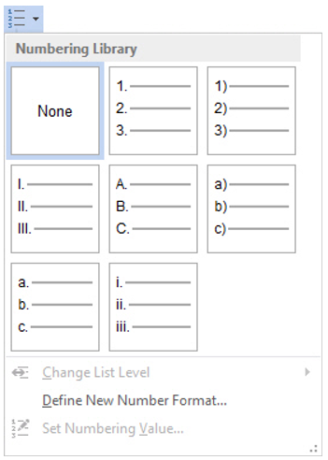
Figure 30-changing numbering

Applying and formatting borders and shading
Add borders and shading to your text. Select the text and then in the home from the Paragraph group click on the 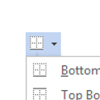 button to apply borders and on the 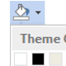 button to apply shading to the text.
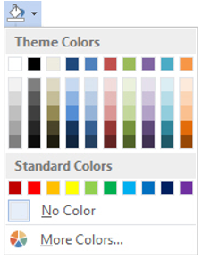
Figure 31-shading palette
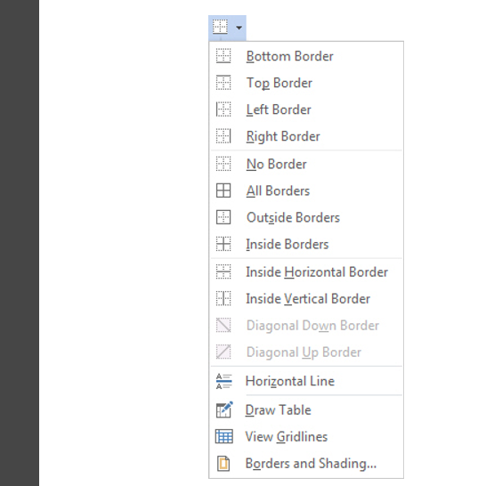
Figure 32-applying borders
At the end check the print preview of the pamphlet and save it with the specified name at the specified location.
Conclusion
After following the above steps, we can learn how to use Ms Word template and make changes in it. How to add bullets and numbering in the documents and how to apply borders and shading to the selected text.

Sample:
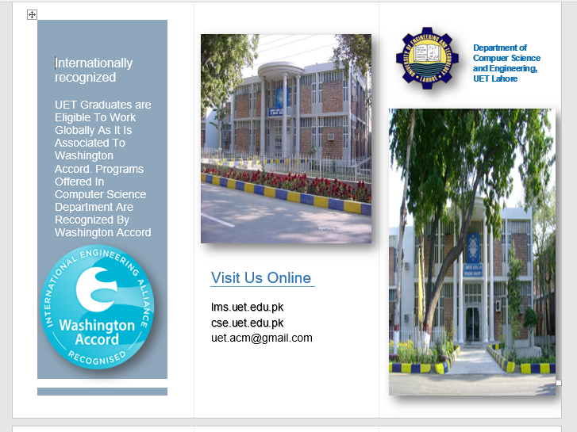
Figure 33: Sample Document (back side)
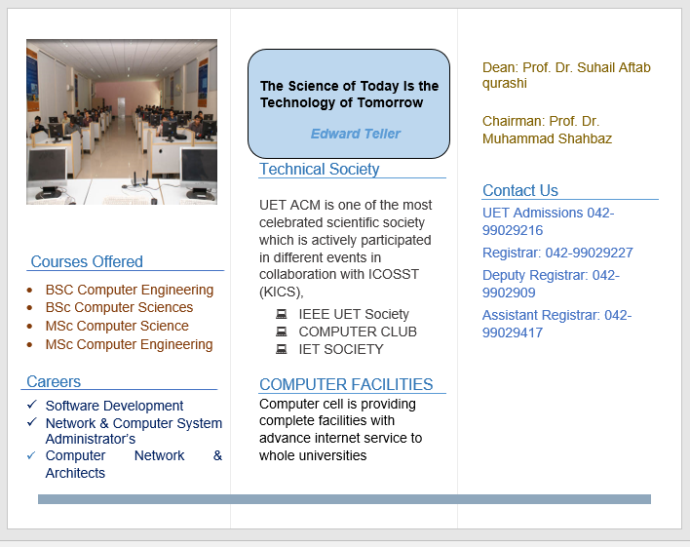
Figure 34: Sample document (inner side)

CS-141L Introduction to computing
Create a bio data form and fill it.
Objectives
To learn how to create simple forms using simple and basic features of MS Word.
Processing steps
- Open a New blank Word document. Set the paper size to letter and start creating a form according to the given specimen.
- Insert picture in the form (UET logo) and select “in line with text’’ from the wrap text option and add text.
- Start entering text in the form. Shapes will be inserted in the form. To insert shapes in the form, select the insert tab and in the illustrations group, click on the shapes option and select the desired shape.
Inserting shapes
In this form, we have used rectangle shape to insert picture and symbols and line shape to underline the text.
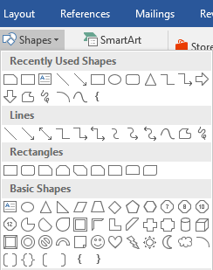
Figure 35-shapes
Inserting symbols
Symbols must be inserted in the form. To do this select the insert tab and in the symbols group click on the symbol button.
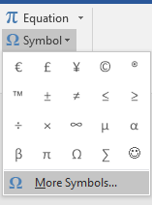
Figure 36-symbols
To view all symbols, click on the ‘’more symbols’’ options. Symbols dialog box appears. And select the tick symbol which is used in the form in this assignment,
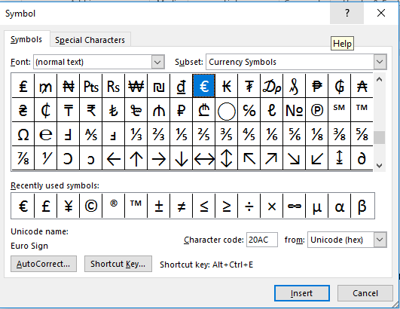
Figure 37-symbols dialog box
After completing the form, fill the form with appropriate information and save it.
Conclusion
After following the above steps, we can learn how to insert shapes in the document and insert text and pictures in those shapes and how to insert symbols in the document.

Sample:
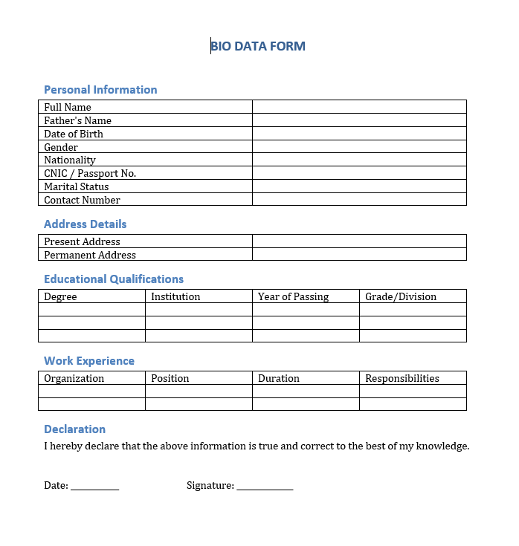
Figure 38: Sample document

